Assignment No: 4
Name: Prasanna Khebade Roll No: 15 PRN: 12311687 Div: CS (AI) - B
Title: Client server programs using TCP Berkeley socket.
Problem Statement: Write the client server programs using TCP Berkeley socket primitives for wired /wireless network for following a. to say Hello to Each other b. File transfer.
Course Objective: To learn transport layer and application layer protocols used in the Internet.
Course Outcome: Develop Client-Servers by the means of correct standards, protocols and technologies.
Tools Required: Eclipse, Java.
Theory:
- Introduction:
Network programming is the practice of writing programs that run across multiple devices connected via a network. In Java, the java.net package provides classes and interfaces to handle low‑level communication so developers can focus on application logic. It supports two main protocols: TCP — a reliable, connection‑oriented protocol (usually combined with IP as TCP/IP), and UDP — a lightweight, connectionless protocol for sending packets without guaranteed delivery.
- Berkeley Socket Primitives
The Berkeley Sockets API, developed at UC Berkeley, underpins network communication in UNIX, Linux, and Windows. For TCP, key primitives include:
socket() – Create a socket descriptor.
bind() – Assign socket to a local IP and port.
listen() – Set socket to accept incoming connections.
accept() – Accept and return a new socket for communication
connect() – Client initiates a server connection.
send()/write() – Transmit data.
recv()/read() – Receive data.
close() – Terminate the connection.
- Socket Programming Flow (TCP):
Server: Create socket → bind to IP & port → listen for clients → accept connections → exchange data via read()/write() → close.
Client: Create socket → connect to server → exchange data → close connection.
- Socket Programming using JAVA:
In Java TCP communication, the server uses a ServerSocket to listen on a port and waits for connections using accept(). The client uses a Socket to connect to the server’s host and port. Once connected, both can exchange data through input/output streams. Java provides java.net.ServerSocket for servers and java.net.Socket for clients, enabling two‑way communication.
Programs:
We have Successfully Wrote a client server programs using TCP Berkeley socket primitives for following
- Say Hello to Each other
Server:
import java.io.*;
import java.net.*;

public class ChatServer {
public static void main(String[] args) {
int port = 65432;

try (ServerSocket serverSocket = new ServerSocket(port)) {
System.out.println("Server started. Waiting for client...");
try (Socket clientSocket = serverSocket.accept();
BufferedReader in = new BufferedReader(new InputStreamReader(clientSocket.getInputStream()));
PrintWriter out = new PrintWriter(clientSocket.getOutputStream(), true);
BufferedReader userInput = new BufferedReader(new InputStreamReader(System.in))) {

System.out.println("Client connected.");
while (true) {
String msg = in.readLine();
if (msg == null) break;
System.out.println("Client says: " + msg);

if (msg.trim().equalsIgnoreCase("bye")) {
out.println("bye");
break;
}

System.out.print("Server: ");
String reply = userInput.readLine();
out.println(reply);

if (reply.equalsIgnoreCase("bye")) {
break;
}
}
}
} catch (IOException e) {
System.out.println("Error: " + e.getMessage());
}
}
}
Client:
import java.io.*;
import java.net.*;

public class ChatClient {
public static void main(String[] args) {
String host = "192.168.56.1";
int port = 65432;

try (Socket socket = new Socket(host, port);
BufferedReader userInput = new BufferedReader(new InputStreamReader(System.in));
PrintWriter out = new PrintWriter(socket.getOutputStream(), true);
BufferedReader in = new BufferedReader(new InputStreamReader(socket.getInputStream()))) {

System.out.println("Type your messages. Type 'bye' to quit.");
while (true) {
System.out.print("Client: ");
String msg = userInput.readLine();
out.println(msg);

if (msg.equalsIgnoreCase("bye")) {
break;
}

String response = in.readLine();
System.out.println("Server says: " + response);

if (response != null && response.trim().equalsIgnoreCase("bye")) {
break;
}
}
} catch (IOException e) {
System.out.println("Error: " + e.getMessage());
}
}
}

Result:
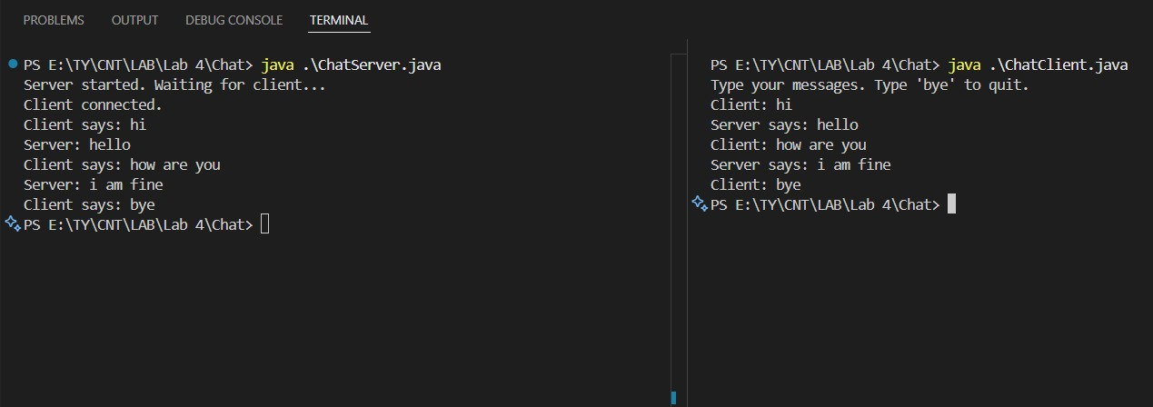
- File Sharing:
Server:
import java.io.*;
import java.net.*;

public class FileServer {
public static void startServer(String host, int port, String filename) {
try (ServerSocket serverSocket = new ServerSocket(port, 1, InetAddress.getByName(host))) {
System.out.println("Server listening on " + host + ":" + port);
try (Socket clientSocket = serverSocket.accept();
InputStream in = clientSocket.getInputStream();
OutputStream out = clientSocket.getOutputStream()) {

System.out.println("Connected by " + clientSocket.getInetAddress());

byte[] commandBuffer = new byte[1024];
int commandLen = in.read(commandBuffer);
String command = new String(commandBuffer, 0, commandLen);

if (command.equals("GETFILE")) {
File file = new File(filename);
if (file.exists()) {
out.write("FILE_FOUND".getBytes());
out.flush();

try (FileInputStream fileIn = new FileInputStream(file)) {
byte[] buffer = new byte[1024];
int bytesRead;
while ((bytesRead = fileIn.read(buffer)) != -1) {
out.write(buffer, 0, bytesRead);
}
}
out.write("__END__".getBytes());
out.flush();
} else {
out.write("FILE_NOT_FOUND".getBytes());
out.flush();
}
}
}
} catch (IOException e) {
e.printStackTrace();
}
}

public static void createSampleFile(String filename) {
try (FileWriter writer = new FileWriter(filename)) {
writer.write("This is a sample file for transfer via TCP socket.");
} catch (IOException e) {
e.printStackTrace();
}
}

public static void main(String[] args) {
String filename = "sample.txt";
createSampleFile(filename);
startServer("127.0.0.1", 12345, filename);
}
}

Client:
import java.io.*;
import java.net.*;

public class FileClient {
public static void getFile(String host, int port, String filename) {
try (Socket socket = new Socket(host, port);
OutputStream out = socket.getOutputStream();
InputStream in = socket.getInputStream();
FileOutputStream fileOut = new FileOutputStream(filename)) {

out.write("GETFILE".getBytes());
out.flush();

byte[] status = new byte[1024];
int statusLen = in.read(status);
String statusMsg = new String(status, 0, statusLen);

if (statusMsg.equals("FILE_FOUND")) {
byte[] buffer = new byte[1024];
while (true) {
int bytesRead = in.read(buffer);
if (bytesRead == -1) break;
String chunk = new String(buffer, 0, bytesRead);
if (chunk.contains("__END__")) {
fileOut.write(chunk.replace("__END__", "").getBytes());
break;
}
fileOut.write(buffer, 0, bytesRead);
}
System.out.println("File received and saved as " + filename);
} else {
System.out.println("File not found on server.");
}
} catch (IOException e) {
e.printStackTrace();
}
}

public static void main(String[] args) {
getFile("127.0.0.1", 12345, "received.txt");
}
}

Result:
